- Xuan sold 9 used books for $9.80. With the money from these sales, she bought 4 new books and had $37.80 left over. What was the average amount Xuan paid for each new book?  - $5.60  - $9.45  - $10.08  - $12.60  - $22.05  - A point at (-5,7) in the standard (x,y) coordinate plane is translated right 7 coordinate units and down 5 coordinate units. What are the coordinates of the point after the translation?  - (-12,12)  - (0, 0)  - (2, 2)  - (2, 12)  - (12,12)  - Shantiel left her home at 9:00 a.m. on Tuesday and traveled 648 miles. When she arrived at her destination it was 3:00 a.m. the next day. Given that her home and her destination are in the same time zone, which of the following is closest to her average speed, in miles per hour, for this trip?  - 72  - 54  - 36  - 31  - 18  - The text message component of each of Juan’s monthly phone bills consists of $10.00 for the first 300 text messages sent that month, plus $0.10 for each additional text message sent that month. On Juan’s most recent phone bill he was charged a total of $16.50 for text messages. For how many text messages in total was Juan charged on this bill?  - 235  - 285  - 315  - 365  - 465  - Which of the following matrices is equal to  $$\left[\begin{matrix}9 & 8 \\ -4 & 7\end{matrix}\right]+\left[\begin{matrix}-6 & 6 \\ 5 & 4\end{matrix}\right]?$$  - $\left[\begin{matrix}3 & 14 \\ 1 & 11\end{matrix}\right]$  - $\left[\begin{matrix}3 & 14 \\ 9 & 11\end{matrix}\right]$  - $\left[\begin{matrix}15 & 14 \\ 9 & 11\end{matrix}\right]$  - $\left[\begin{matrix}17 & 0 \\ 3 & 9\end{matrix}\right]$  - $\left[\begin{matrix}-14 & 86 \\ 59 & 4\end{matrix}\right]$  - The function, f, is defined by $f\left(x,y\right)={3x}^{2}-4y$. What is the value of $f(4,3)$?  - 11  - 24  - 36  - 65  - 132  - A certain group consists of 5 children, 3 of whom are age 10 and 2 of whom are age 5. What is the mean age of the children in the group?  - 5  - 7  - 7.5  - 8  - 10  - In the figure shown below, $\overline{AC}||\overline{DE}$; $BD=AG$; D and E, are on $\overline{AB}$ and $\overline{BC}$, respectively; $AC=8 feet$; and the height of $∆ABC$ is 10 feet. What is DE, in feet?  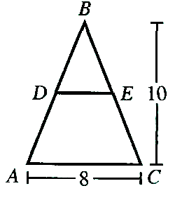  - 2  - 3  - 4  - 5  - 6 | DO YOUR FIGURING HERE.  DO YOUR FIGURING HERE.

- In a poll of 500 registered voters, 337 voters favored a proposal to increase funding for local schools. Suppose the poll is indicative of how the 22,000 registered voters will vote on the proposal. Which of the following values is closest to how many of the 22,000 registered voters will be expected to vote in favor of the proposal?  - 13,200  - 14,830  - 21,840  - 22,000  - 32,640  - Diego purchased a car that had a purchase price of $13,400, which included all other costs and tax. He paid $400 as a down payment and got a loan for the rest of the purchase price. Diego paid off the loan by making 48 payments of $300 each. The total of all his payments, including the down payment, was how much more than the car’s purchase price?  - $1,000  - $1,400  - $13,000  - $14,400  - $14,800  - In the standard (x,y) coordinate plane below, what is the slope of the line $4x+7y=9$?  - $-\frac{4}{7}$  - $\frac{4}{9}$  - - 4  - 4  - 9  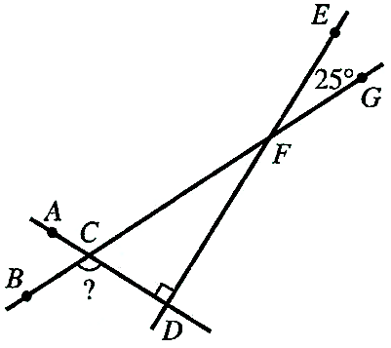  - In the figure below, $\overset{⃡}{AD}$ intersects $\overset{⃡}{BG}$ at C and is perpendicular to $\overset{⃡}{DE}.$ Line $\overset{⃡}{DE}$ intersects $\overset{⃡}{BG}$ at F. Given that the measure of $∠EFG$ is $25°$, what is the measure of $∠BCD$?  - $65°$  - $115°$  - $120°$  - $130°$  - $155°$ | DO YOUR FIGURING HERE

- What is the sum of the 2 solutions of the equation  $x^{2}+x-30=0$?  - -30  - -6  - -1  - 0  - 5  - The volume of a sphere is $\frac{4πr^{3}}{3}$, where r is the radius of the sphere. What is the volume, in cubic yards, of a sphere with a diameter of 4 yards?  - $\frac{32}{3}π$  - $\frac{64}{3}π$  - $32π$  - $48π$  - $\frac{256}{3}π$  - What is the smallest integer greater than $\sqrt{85}$?  - 5  - 9  - 10  - 12  - 43  - The 3 statements below are true for the elements of sets A, B, C, and D.  - All elements of A are elements of B.  - All elements of C are elements of D.  - No elements of D are elements of B.  Which of the following statements must be true?  - All elements of A are elements of C.  - All elements of B are elements of D.  - All elements of C are elements of B.  - No elements of A are elements of B.  - No elements of A are elements of C.  - In the standard (x,y) coordinate plane, the midpoint of $\overline{AB}$ is at (2,1), and A is at (8,10). What is the x-coordinate of B?  - -4  - -6  - -8  - 3  - 5 | DO YOUR FIGURING HERE

- Lena will pick 1 card at random from a pack of 25 baseball cards. Each card features the fielding position for 1 of 25 different baseball players. Each player in the pack has only 1 fielding position. The table below lists the frequency of fielding positions in the pack. What is the probability that the card Lean picks will feature an outfielder or a pitcher?  Fielding Position Frequency  Catcher Infielder Pitcher Outfielder 4 6 8 7  - 9%  - 28%  - 32%  - 56%  - 60%  - According to a soil analysis, a certain lawn requires an application of 40.0 kg of nitrogen phosphate when the average temperature is 75.0$°F$. To avoid burning the grass, the required application amount decreases 1.2 kg for each 1.0$°F$ that the average temperature is above $75.0°F$. To the nearest 0.1 kg, what is the required application amount of nitrogen phosphate when the average temperature is $83.0°F$?  - 30.4  - 30.8  - 33.3  - 38.4  - 38.8  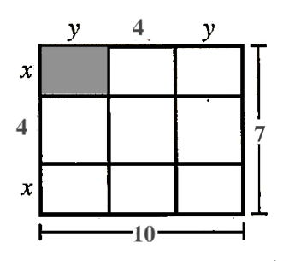  - In the figure below, all segments that meet do so at right angles. What is the area, in square units, of the shaded region?  - 2  - $2\frac{1}{2}$  - $4\frac{1}{2}$  - $3$  - $1\frac{1}{2}$  - The perimeter of a certain scalene triangle is 80 inches. The side lengths of the triangle are represented by $2x, 4x+20$and $x+39$, respectively. What is the length, in inches, of the longest side of the triangle?  - 3  - 21  - 6  - 42  - 32  - How many different ways can Goku arrange 8 fighting  moves against Frieza?  - 24  - 64  - 1,680  - 40,320  - 322,560  - The sum of 4 and 300% of 1 has the same value as which of the following calculations?  - 100% of 4  - 300% of 1  - 700% of 1  - 700% of 4  - 400% of 3  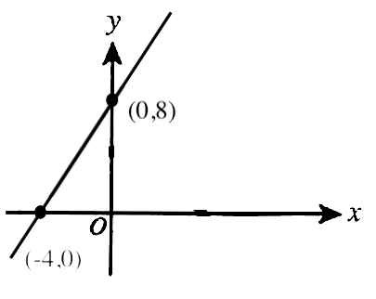  - The graph in the standard (x,y) coordinate plane below is represented by one of the following equations. Which equation?  - $y=2x-4$  - $y=-\frac{1}{2}x-4$  - $y=\frac{1}{2}x-4$  - $y=-2x+8$  - $y=2x+8$  - Kamini is constructing the kite shown below. The kite includes 2 perpendicular supports, one of length 40 inches and the other of length 28 inches. The ends of the supports are connected with string to form a 4-sided figure that is symmetric with respect to the longer support. A layer of paper will cover the interior of the 4-sided figure. Which of the following is closest to the area, in square inches, that Kamini will cover with paper?  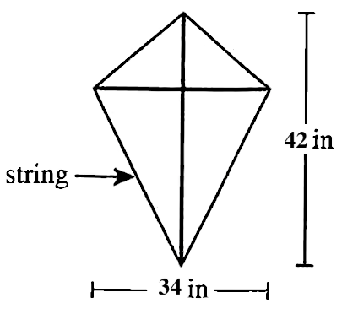  - 714  - 578  - 882  - 760  - 1,428 | DO YOUR FIGURING HERE  DO YOUR FIGURING HERE.

Use the following information to answer  questions 26-29.  The top view and side view of a 40-foot long swimming pool are shown in the figure below. All dimensions given are in feet.  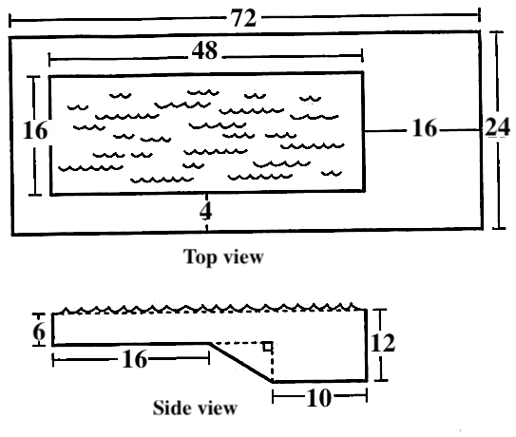  The top view shows the top rectangular surface of the pool and the surrounding rectangular patio. All 4 walls of the pool are vertical and perpendicular to the top surface. The side view shows a cross section along the length of the pool. All cross sections parallel to the side view are congruent. The shallow end has a constant depth of 6 ft. The deep end has a constant depth of 12 ft. A rectangular surface connects the shallow and deep ends.  - What is the area, in square feet, of the patio surrounding the pool?  - 348  - 768  - 900  - 960  - 1,728  - Johann put up a fence along the outer edge of the patio. Given that the materials for the fence cost $12 per foot, what was the total cost of the materials for the fence?  - $2,304  - $1,152  - $1,536  - $9,216  - $20,736  - A full lap is 4 times the length of the pool. Johann swam 6 full laps of the pool in $8\frac{1}{4}$ minutes. Which of the following values is closest to Johann’s average swimming speed, in feet per minute?  - 160  - 140  - 100  - 94  - 70  - The side view of the pool is placed in the standard (x,y) coordinate plane, keeping the same orientation and scale, such that both vertical segments showing depth are parallel to the y-axis. Which of the following values is closest to the slope of the line segment connecting the shallow end to the deep end?  - -0.27  - -0.80  - -1.00  - -22.8  - -3.67  - A construction company builds 3 different models of houses (A, B, and C). They are order all the bathtubs, shower stalls, and sinks for the house contains different number of bathroom fixtures. The table below give the number of each kind of these fixtures required for each model and the cost to the company, in dollars, of each type of fixture.  Fixture Model A B C Bathtubs Shower stalls Sinks 2 1 1 2 0 4 1 1 3 Fixture Cost Bathtubs Shower stalls Sinks $200 $160 $140  The company plans to build 2 A’s, 2 B’s, and 4 C’s. What will be the cost to the company of exactly enough of these bathroom fixtures to put the required number in all of these houses?  - $2,440  - $4,000  - $6,440  - $1,280  - $8,000  - Shown below, a board 7 feet 4 inches long is cut into 4 equal parts. What is the length, to the nearest inch, of each part?  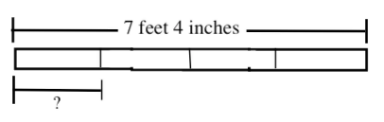  - 3 feet 2 in  - 4 feet 4 in  - 3 feet 8 in  - 2 feet 6 in  - 1 foot 10 in  - A ball is thrown down from a ledge and bounces 20 ft into the air. On each bounce, the ball travels $\frac{1}{4}$ less than the previous bounce’s distance. After 5 total bounces, how far is the ball from the ground?  - $6\frac{21}{64}$  - $\frac{5}{4}$  - 0  - $\frac{5}{64}$  - $\frac{20}{64}$  - In the standard (x,y) coordinate plane, $\acute{A}$ is the image resulting from the reflection of the point $A\left(-4,-6\right)$ across the y-axis What are the coordinates of $\acute{A}$?  - (6, -4)  - (-6,4)  - (-6, -4)  - (4, -6)  - (-4,6) | DO YOUR FIGURING HERE.  DO YOUR FIGURING HERE  DO YOUR FIGURING HERE

- To increase the mean of 3 numbers by 5, by how much would the sum of the 3 numbers have to increase?  - $\frac{3}{5}$  - 5  - $\frac{5}{3}$  - 15  - 12  - Which of the following expressions is equivalent to ${(4+2x)}^{-50}$?  - ${-4}^{-50}-{(2x)}^{50}$  - $\frac{1}{{(4+2x)}^{50}}$  - $\frac{1}{4^{50}}+\frac{1}{{(2x)}^{50}}$  - $\frac{1}{8x^{50}}$  - $-200-100x$  - Consider the graph of the equation $y=\frac{(2x+5)(2x-4)}{(x-4)(x+6)}$ in the standard (x,y) coordinate plane, Which of the following equations represents one vertical asymptote of the graph?  - $x=-4$  - $x=-\frac{2}{5}$  - $x=\frac{1}{2}$  - $x=-6$  - $x=-\frac{5}{2}$  - For every pair of real numbers x and y such that xy=0 and $\frac{x}{y}=0$, which of the following statements is true?  - $x=0 and y=0$  - $x≠0 and y=0$  - $x=0 and y≠0$  - $x≠0 and y≠0$  - None of the statements is true for every such pair of real numbers x and y. | DO YOUR FIGURING HERE.

Use the following information to answer  questions 38-40  Julie recently vacationed to NY. While there, he visited Jersey Park. Afterward, she took a 2.4 mile walk from the Statue of Liberty. A tour guide name Mike informed her that 450,000 lbs of copper were used to build the tower, which stands 151 feet tall.  - Julie’s walk lasted 45 minutes. Which of the following values is closest to the average speed of Julie, in miles per hour?  - 3.2  - 3.0  - 4.5  - 2.4  - 3.6  - When written in scientific notation, the number rivets used to build the Eiffel Tower is equal to which of the following expressions?  - $4.5×{10}^{4}$  - $4.5×{10}^{6}$  - $4.5×{10}^{5}$  - $45×{10}^{4}$  - $45×{10}^{5}$  - At a certain point, the angle of elevation formed by the level ground and the line from that point to the top of the Statue of Liberty is $60°$. Which of the following expression is equal to the distance, in meters, from the point to the top of the tower?  - $151\sin{60°}$  - $151\cos{60°}$  - $151\tan{60°}$  - $\frac{151}{\sin{60°}}$  - $\frac{\sin{60°}}{151}$ | DO YOUR FIGURING HERE.

- When the vector $ai+3j$ is added to the vector $-2i+bj,$ the sum 6$i-4j$. What are the values of a and b?  - Given $C=1,000b^{3}+50$, which of the following is an expression for b in terms of c?  - ${\left(\frac{c}{10}-5\right)}^{\frac{1}{3}}$  - ${\left(\frac{c}{10}+5\right)}^{\frac{1}{3}}$  - ${\frac{1}{10}\left(c-50\right)}^{\frac{1}{3}}$  - $c^{3}+5$  - ${10c}^{3}+50$  - Given $f\left(x\right)=x^{2}+3x$ and $g\left(x\right)=x-2$, what is $f(g(x))$?  - The diameter of one circle is 12 inches long. The diameter of a second circle is 18% longer than the diameter of the first circle. To the nearest square inch, how much larger is the area of the second circle than the area of the first circle?  - 7  - 28  - 44  - 64  - 254  - What is the difference between the second and the seventh prime number?  (Note: 2 is the first prime number.)  - For all real values of x, which of the following equations is true?  - $\sin^{2}\left(7x\right)+\cos^{2}\left(7x\right)=7$  - $\sin^{2}\left(7x\right)+\cos^{2}\left(7x\right)=1$  - $7\sin\left(7x\right)+7\cos\left(7x\right)=14$  - $sin\left(7x\right)+\cos\left(7x\right)=7$  - $\sin\left(7x\right)+\cos\left(7x\right)=1$ | DO YOUR FIGURING HERE.

- In the figure shown below, A, B, and D lie on a circle whose center is O, a diameter is $\overline{AB}$, $\overline{CD}$, is perpendicular to $\overline{AB}$ at C, the length of $\overline{AD}$ is 5 m, and the length of $\overline{BD}$ is 12 m. What is the length, in meters, of $\overline{AC}$?  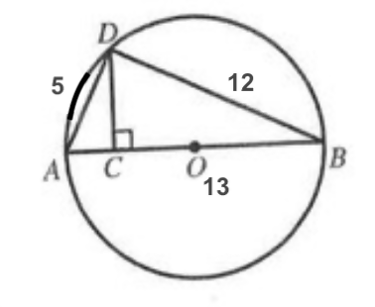  - $\frac{20}{13}$  - $\frac{25}{13}$  - 13  - $3$  - $\frac{5}{4}$  - If a and b are real numbers such that $a>0$ and $b<0$, then which of the following is equivalent to $\left|a\right|-|b|$?  - $|a-b|$  - $\left|a+b\right|$  - $\left|a\right|+|b|$  - $a+b$  - $a-b$  - If $y<x$ and $x<7$, then what is the greatest possible integer value of $x+y$?  - 0  - 1  - 11  - 12  - 13  - Given that y varies directly as the square root of x, if  $y=16$ when $x=4$, what is y when $x=9$? | DO YOUR FIGURING HERE.

- Shown below in the standard (x,y) coordinate plane are 2 circles and 1 ellipse, each centered at (0,0). The larger circle has equation $x^{2}+y^{2}=36$ and intersects the ellipse at exactly 2 points, both on the x-axis. The smaller circle has equation $x^{2}+y^{2}=9$ and intersects the ellipse at the exactly 2 points, both on the y-axis. Which of the following equations represents the ellipse?  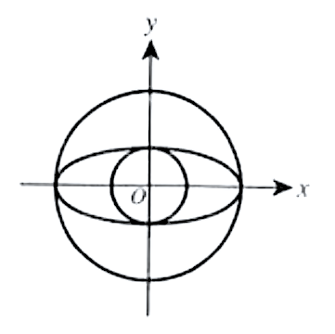  - $\frac{x^{2}}{3}+\frac{y^{2}}{6}=1$  - $\frac{x^{2}}{9}+\frac{y^{2}}{36}=1$  - $\frac{x^{2}}{6}+\frac{y^{2}}{3}=1$  - $\frac{x^{2}}{36}+\frac{y^{2}}{9}=1$  - $\frac{x^{2}}{144}+\frac{y^{2}}{36}=1$  - The mean of 5 integers is 57. The median of these 5 integers is 62. Three of the integers are 21,62, and 99. If 21 is the minimum of the data, what is the largest possible value for the one of the missing terms?  - 22  - 62  - 81  - 103  - 181  - An integer is deficient if it’s positive integer divisors, excluding the integer itself, have a sum that is less than the integer. How many of the integers 8, 18, 36, and 41 are deficient?  - 0  - 1  - 2  - 3  - 4  - Vanna ran at a rate of 8 miles per hour for 20 minutes and then walked at a rate of 3 miles per hour for 5 minutes. Which of the following gives the average rate, in miles per hour, at which she walked/ran over this 25-minute period? | DO YOUR FIGURING HERE.

- The ratio of Alani’s height to Baahir’s height is 6:7. The ratio of Baahir’s height to Connor’s height is 5:4. What is the ratio of Alani’s height to Conner’s height?  - For all $x>0$, which of the following expression is Not equivalent to $\sqrt{x\sqrt{x}}$?  - $x^{\frac{3}{4}}$  - $x^{\frac{1}{4}}$  - $\sqrt[4]{x^{3}}$  - $\sqrt[4]{x\sqrt{x^{4}}}$  - $\sqrt[8]{x^{6}}$  - If the length of a rectangle is increased by 30% and the width is decreased by 15%, the area of the resulting rectangle is larger than the area of the original rectangle by what percent?  - 2.5%  - 10.5%  - 15%  - 22.5%  - 35%  - Five balls, numbered 1,2,3,4, and 5, are placed in a bin. Two balls are drawn at random without replacement. What is the probability that the sum of the numbers on the balls drawn in 5? | DO YOUR FIGURING HERE
- $\frac{1}{5}$
- $\frac{2}{5}$
- $\frac{4}{5}$
- $\frac{5}{9}$
- $\frac{4}{25}$

- Consider the family of functions $y=f(x)=2sin x -3$. Which of the following number lines represents the range of the function for all possible values of y?  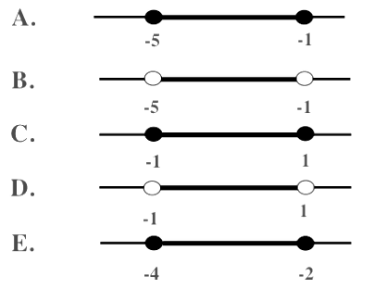  - Tameka calculates that she needs 480 square feet of new carpet. But the type of carpet that she wants is priced by the square yard. Rounded to the nearest whole number, how many square yards of carpet does she need? | DO YOUR FIGURING HERE

